* RoR

incremental -> alt X - alt Y

incremental RoR analysis - two alts, multi alts.

incremental cash flow

CC = P A/i

delta i\*B-A >= MARR → Select B, (cf. |B ini cost| > |A ini cost|)

* B/C Ratio (cf. same unit s.t. AW, PW, FW) (cf. no minus sign)

conventional b/c ratio = (B-D)/C >= 1 → justify

modified b/c ratio = [(B-D)-M&O]/ini cost >= 1 → justify

Profitability index = NCF/ini cost >= 1 → justify

incremental comparison, order of increasing total cost (alt Y - alt X B/C > 1 → select Y, total cost |Y| > |X|)

CER (Cost Effective Ratio) = Equivalent total cost / Total effectiveness measure

order increasing CER

the cumulative cost of projects until the budget limit

* Inflation

Actual $(amount on bills), Constant $(purchasing power in year 0)

i = real rate, f = inflation ratio, if (a.k.a. market rate) = i+f+i\*f

constant $ = actual $/(1+f)^n

pv = constant $ / (1+i)^n = actual $ / {(1+i)^n\*(1+f)^n} = actual $ / (1+if)^n

PW with inflation

constant = actual / (1+f)^n

pw = constant/(1+i)^n = constant\*(P/F,i,n)

pw = actual / (1+i+f+i\*f)^n = actual\*(P/F, if, n)

FW with inflation

the actual amount accumulated -> if

purchasing power in terms of the CV of the future amount -> i

future dollar required to have the same purchasing power as a dollar today without time value of money -> f

maintain the purchasing power of the present sum and earn a real rate of return -> if

Captial Recovery = ini cost - salvage, pmt with if

* Depreciation

Book depreciation: any method / Tax depreciation: MACRS in the US.

P or B: first cost or unadjusted basis

BVt : book value in year t

n : recovery period

MV : market value

S : salvage

dt : depreciation rate in year t

* the land is not depreciable

Straight Lline : annual depriciation charge Dt = (B-S)/n,dt is constant

Declining Balance & Double Declining Balance :

BVt = B(1-d)^t Dt = dBVt-1 = dB(1-d)^(t-1)

d = 1-(S/B)^1/n for DB 2/n for DDB

DDB(d=n\*d)for DB method

DDB(d=d) for DDB method

MACRS

Dt = dt\*B

BVt = B - D1 - D2 - … - Dt

depreciate to Zero, no salvage value (= BVn+1 = 0)

recovery period = n+1, half year convention

Cost Depletion = CDt =first cost / resource capacity

→ amount resource removed \* CDt

Percentage Depletion = PDt = from the table

→ gross income \* table%

GI or R: Gross Income or Revenue

OE: Operation Expense

NOI: GI-OE

D: Depreciation

TI: Taxable Income, GI-OE-D

T: Tax rate, Tax = T\*(GI-OE-D)

NOPAT: TI\*(1-T)

Average tax rate = total tax / TI

(approx)Effective Tax rate, Te

= local rate + (1-local rate) \* federal rate

CFBT = GI - OE - D + S

CFAT = CFBT - (GI - OE - D) \* Te

(cf. negative tax → offset tax only)

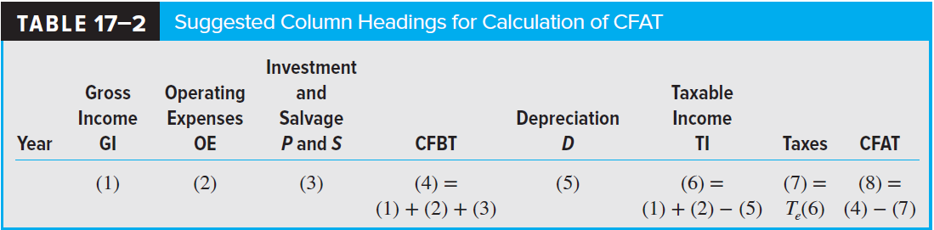

Depreciation Recapture (DR) & Capital Gain (CG)

approx after tax RoR =before tax RoR \* (1-Te)

After-tax replacement analysis

consider DR or CR&CL, if the challenger is selected

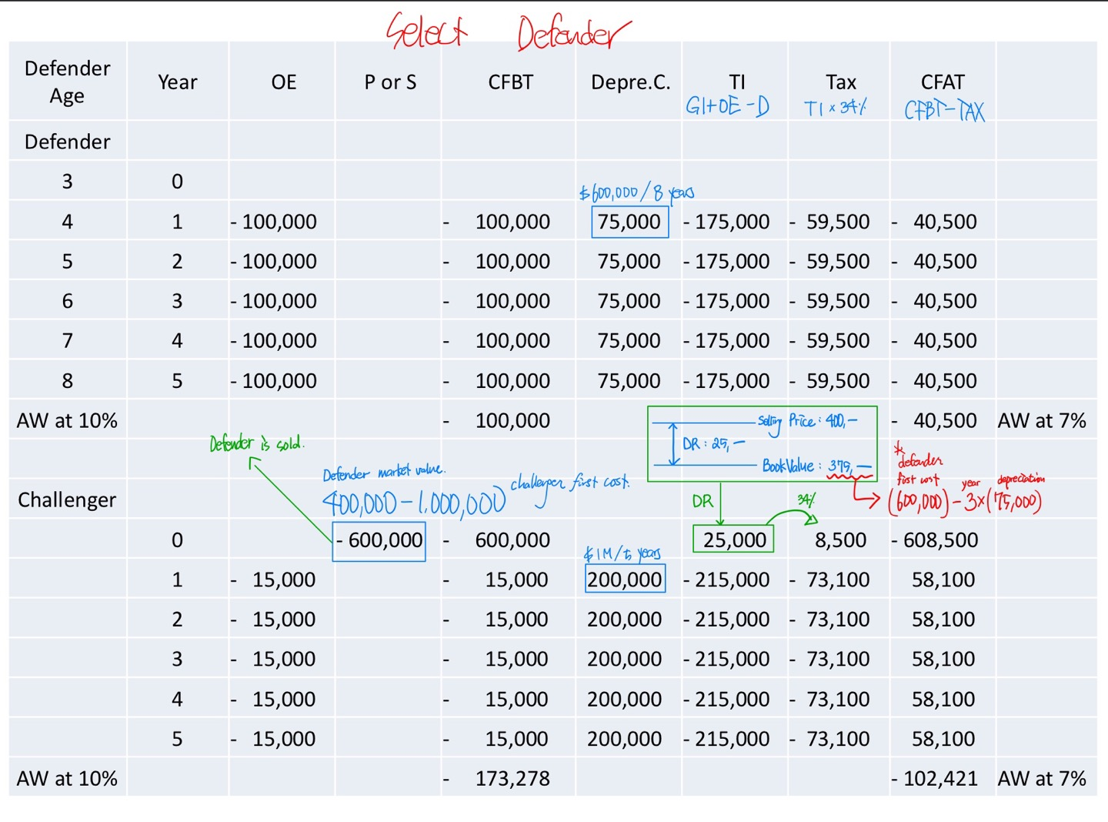

Economic Value Added (EVA) Analysis

→ mingle actual cash flow and noncash flows

AW of EVA = AW of CFAT estimates

EVAt = NOPATt - investment capital

= NOPATt - after-tax MARR \* BVt-1

= TIt \* (1-Te) - i \* (BVt-1)

